REPORT ON “PROFESSIONAL ETHICS IN CONCILIATION AND ARBITRATION PROCEEDINGS” GUEST LECTURE 2022

NAME OF THE PROGRAMME: | “PROFESSIONAL ETHICS IN CONCILIATION AND ARBITRATION PROCEEDINGS” Guest lecture for final year students of LLB IXth SEM(5years) and Vth SEM (3 Years)
DATE AND DAY: | 3rd September, 2022, Saturday
TIME: | 12:00 P.M- 12.50 PM
GOOGLE MEET LINK:
PROGRAMME CO-ORDINATOR: | Asst.Prof. Sarika kamdi,
RESOURCE PERSON : Adv. Wilson Mathew

On 3rd September, 2022, Saturday, guest lecture was conducted by Dr. Ambedkar College, Department of Law, Deekshabhoomi, Nagpur for the final year students of LLB IXth Sem(5 yrs) and VI Semester (3 years course). Total 60 students attended the program. The Program was conducted under the guidance of Prof. Dr. H.V.Menon, Head of the Department of Law, and Associate Professor Dr. Pratima lokhande. in LLB VIth Semester (3years course) in Seminar Hall Room No.4 at 12.00 P.M.

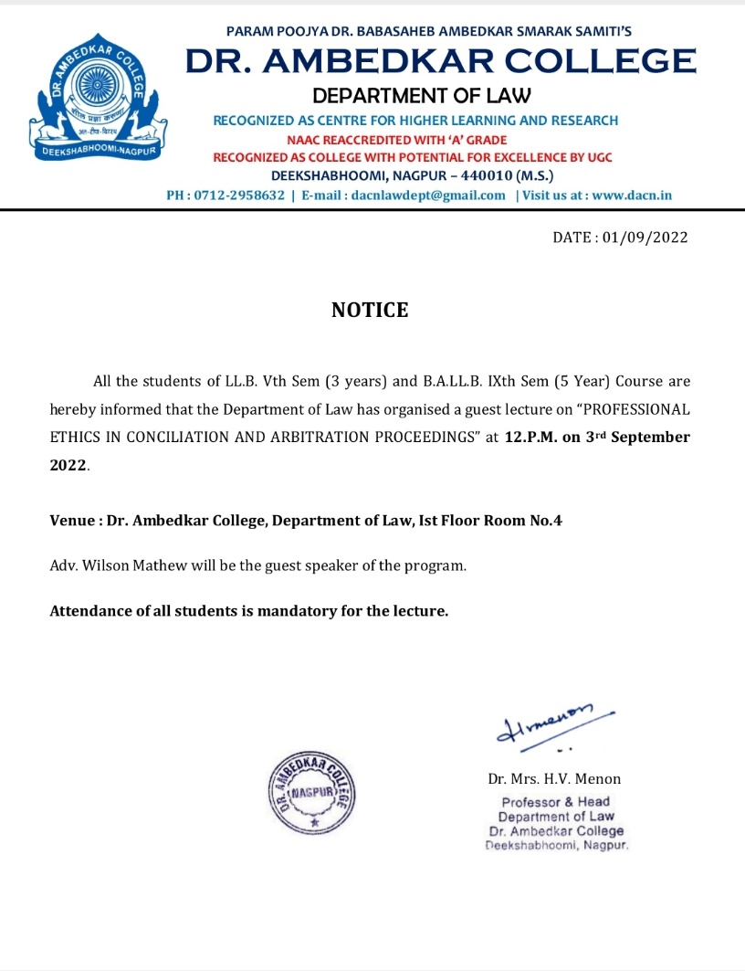
The course content delivered in the lecture is as follows
“PROFESSIONAL ETHICS IN CONCILIATION AND ARBITRATION PROCEEDINGS’’

The speaker of the session Adv. Wilson Mathew presented the keynote address on “PROFESSIONAL ETHICS IN CONCILIATION AND ARBITRATION PROCEEDINGS” and its importance in legal studies.
This lecture was arranged with the motive of sharing the knowledge and practical experience of Adv Wilson Mathew. He started his interaction with the students on a note by asking them how they follow ethics in their day today life. He discussed and analysed the relationship between ethics and law profession. Eventually moved towards the topic law profession and ethics focusing on different aspects of arbitration and conciliation. The relation between them he tried to explain students how ethics are important in noble profession like law. Covered different concept and aspect of social responsibility. He precisely covered conflict of interest in detail and guide the students how to take a call on situation where there is conflict of interest. He discussed the ethical grounds for refusing to accept a brief. Suggested the students to Give the client an informed choice. Then he discussed who can appointed as arbitrators. What is right way to be followed in arbitration and conciliation proceeding. Discussed how commercial laws operate in India, what is position in India and abroad. Shared his national and international arbitration and conciliation experience there by making the session more interactive and informative.

Adv. Wilson Mathew Interacting with students
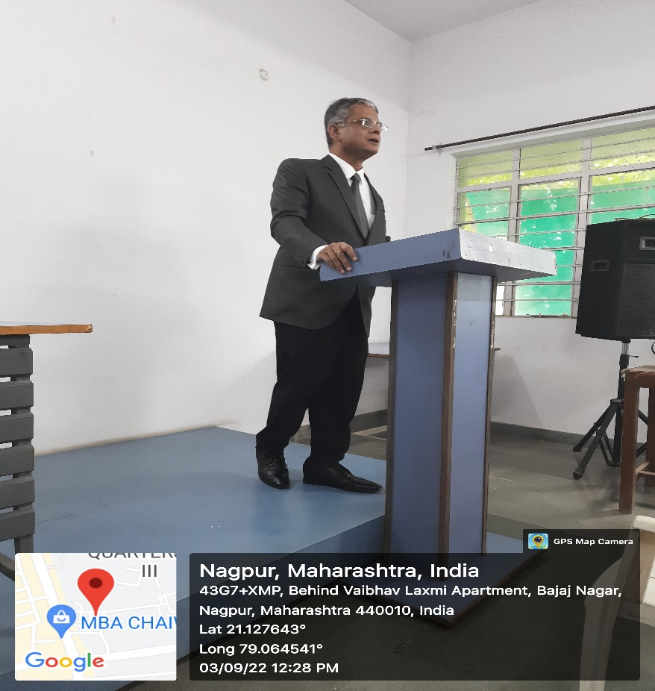

feedback responses obtained from through google form the participants
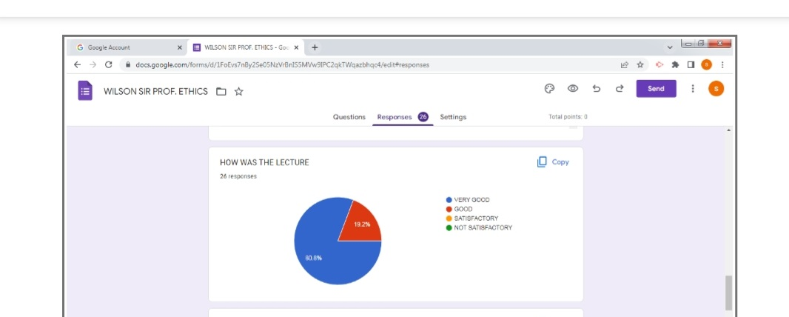

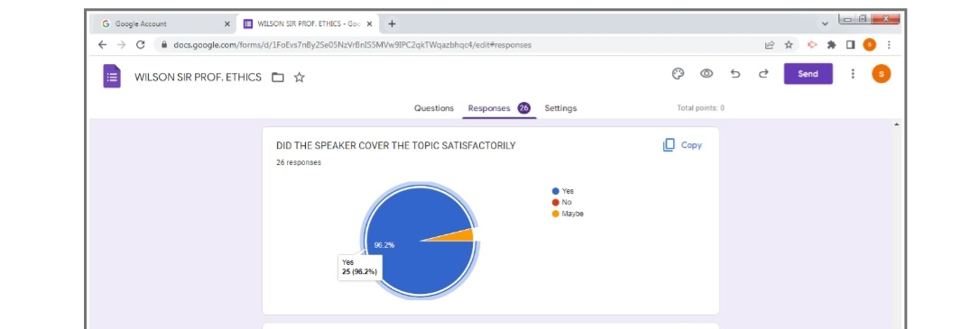
The objectives of the webinar were achieved. The overall session discussion benefitted the faculties and the students. This online lecture would help the participants in their academic studies and also in their future professional career.

